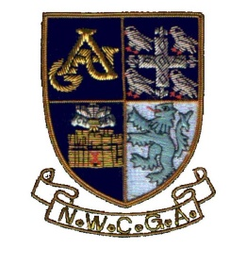
Entry Form:

North Wales
Senior Men’s Open Championship
Royal St. David’s
Golf Club
Monday 28th & Tuesday 29th April 2025

Please use block letters:
Full Name:
Date of Birth: |  | dd |  |  | mm |  | yy
Golf Club (Home):
Handicap Index: |  |  | (max. 6.0)
National ID (CDH):
Address:
Post code:
Contact Tel:
Mobile:
Email:
Date:

Entries to:
Championship Organiser: Elizabeth Youren
Llain Werdd, Llandegfan,
Menai Bridge
Anglesey LL59 5PY

t: 01248 713429 m: 0777 612 2500 : elizabethrandall255@btinternet.com

Payment by BACS: please ask for details when sending in the entry form via post or by email.

This form, completed with the entry fee of £ 50.00, must reach the Championship Organiser by the closing date Sunday 13th April 2025.

Cheques payable to: North Wales Counties Golf Association

